Basic Lex Programs

1.
Aim: LEX program to count the number of vowels and consonants in a given string
Code:
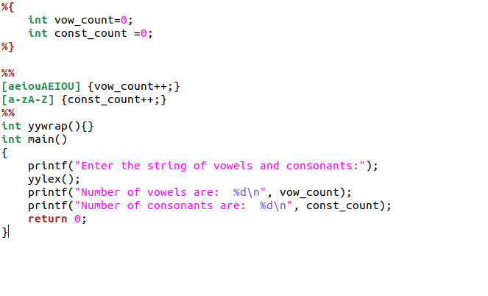
Output:
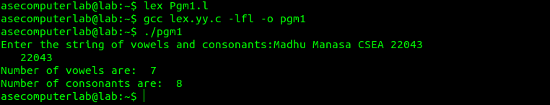

2.
Aim: Lex code for password validation
Code:
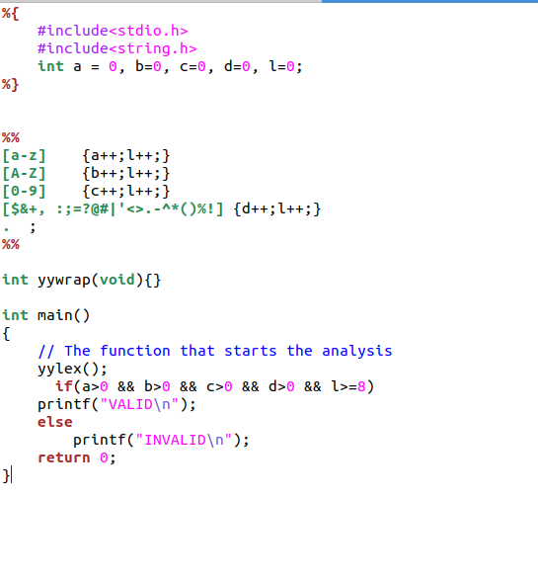
Output:

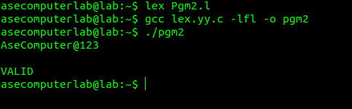

3.
Aim: Lex program to count the number of lines, spaces and tabs
Code:
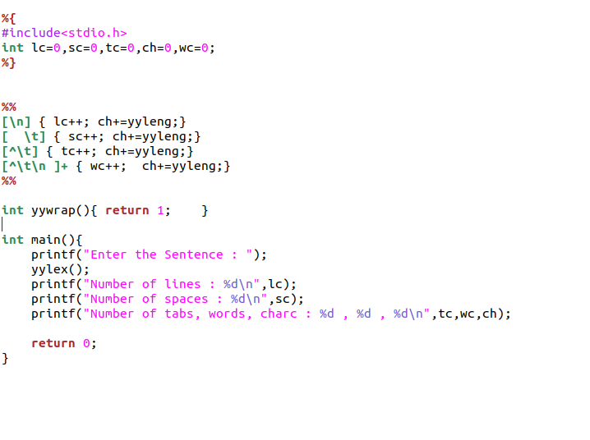

Output:
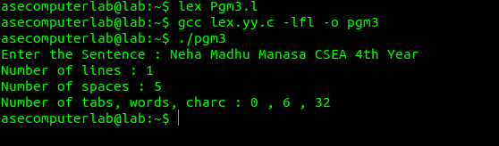

4.
Aim: Lex Program to Identify and Count Positive and Negative Numbers
Code:
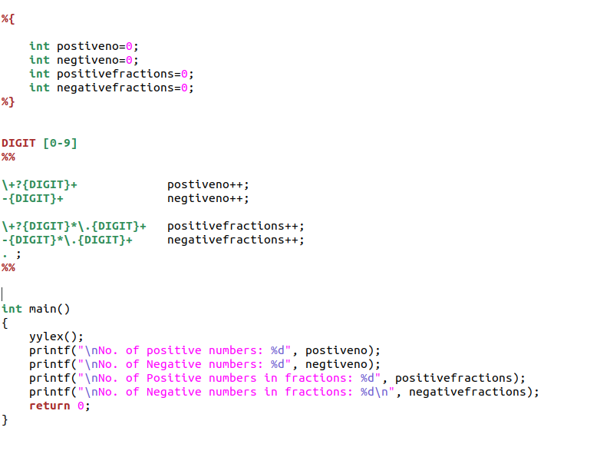
Output:
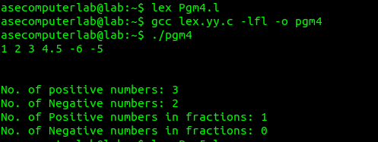

5.
Aim: Lex program to identify the identifier
Code:
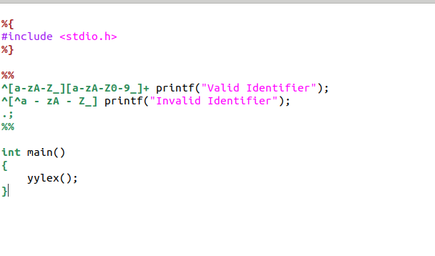
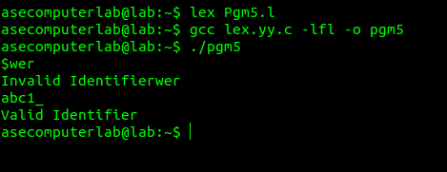
Output:

